**BT & IT**

**ETFS: NPSA Password Reset Procedure**

**Summary**

This document is intended to provide detailed instructions on how to reset the NPSA accounts used by ETFS.

**Prepare**

1. Broadcast outage email to WW-ETFS-Everyone for scheduled outage. This will affect all three instances.
2. Locate and open the ETFS KeePass vault: \\usfile01\Service_Business\Projects\Misc

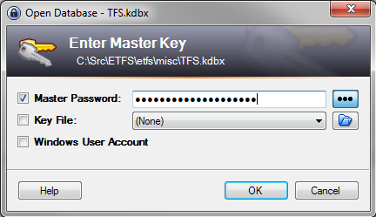

1. Locate the entries for the NPSA accounts that are about to expire.
2. Capture the current password for the account and store in the Notes section of the KeePass entry.

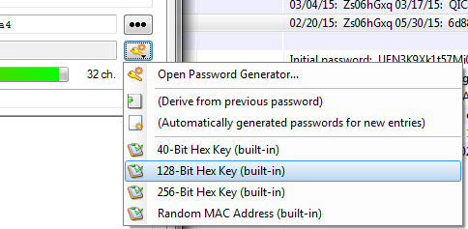

1. Generate passwords using the 128-bit hex key.
2. These are the requirements:
   1. 25 characters
   2. Mixed case
   3. At least 2 special characters (@ & ? ! <) etc.
   4. No two repeating characters (Aa, EE, 11)
   5. No two characters in sequence (12, AB)

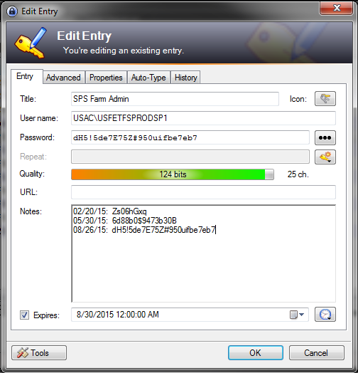

1. Update the password expiration per KeePass entry.

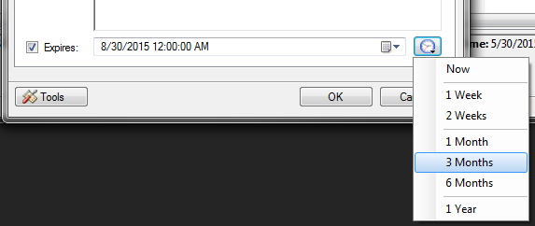

1. Put AT nodes out of service via: <http://gsm>

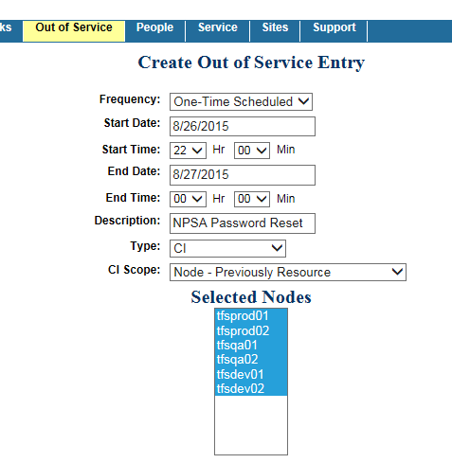

**Stop Team Foundation Server**

1. Wait until Out of Service window starts.
2. Use Remote Desktop to connect to the application tier nodes (tfsprod01, 02), and open IIS Manager. You can find the management applications pinned to the taskbar on all servers.
3. Under sites, stop the Team Foundation Server Health Check site.

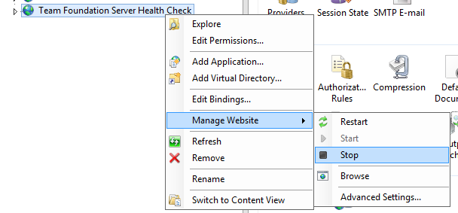

1. Under application pools, stop the Health Check .NET application pool.

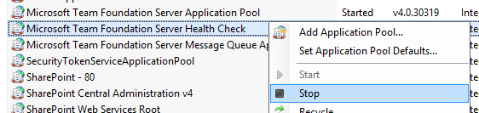

1. Stop TFS Background Agent service.

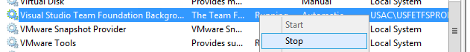

1. Stop SharePoint Timer service.

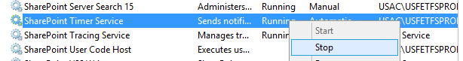

1. Repeat steps 2-6 on second application tier node.

**Reset Passwords**

1. Contact help desk and do a manual reset on all the necessary passwords. 3-1000, Option 1. You **must** be a custodian for the NPSA accounts to reset.
2. Due to the number of passwords that you will be resetting, use Skype for Business with the support engineer to copy/paste the accounts and new passwords. Ask the support engineer to do a “hard reset” using the passwords that you are providing.
3. Update TFS Background Agent service with updated credentials, but do NOT start the service.

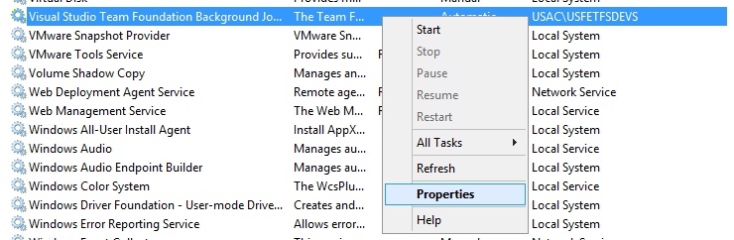

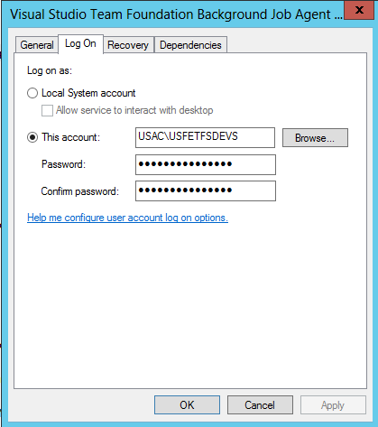

1. Update TFSSERVICE account via TFS Administration Console. TFS Background Agent service will start on its own.

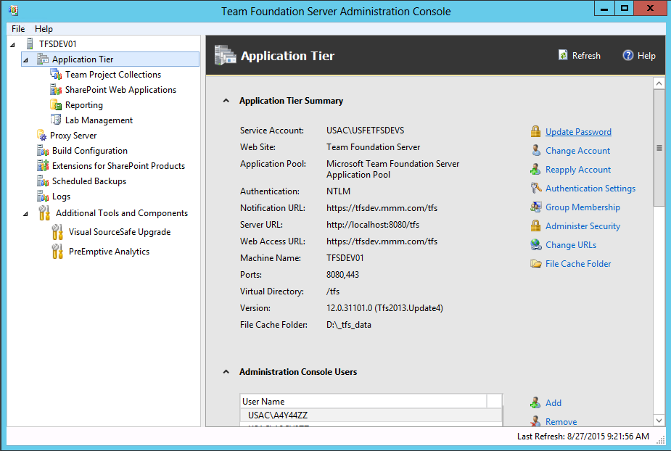

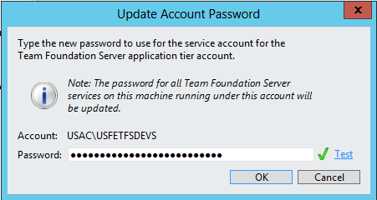

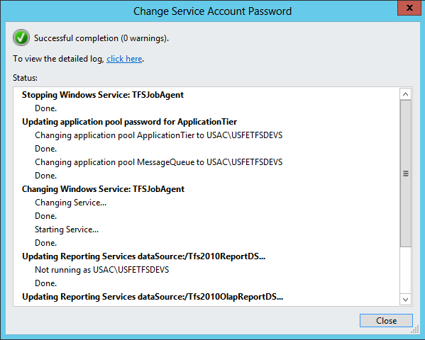

1. Update the password for the TFSREPORTS account via TFS Administration Console.

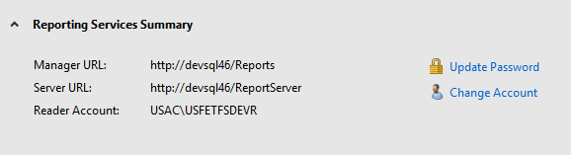

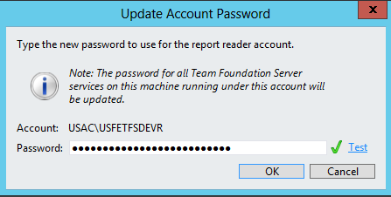

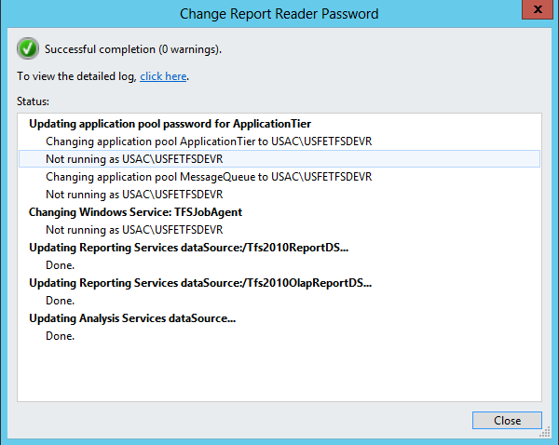

1. Update TFS Health Check application pool on AT nodes. [TFSSERVICE] credentials need to be updated.

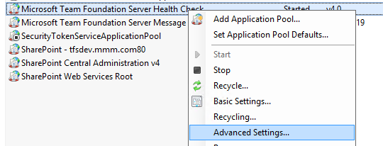

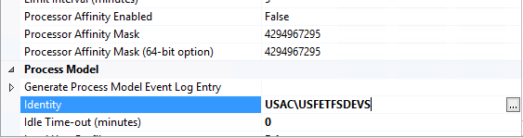

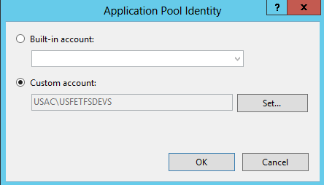

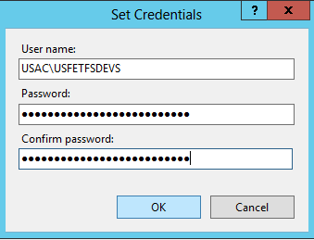

1. Update SharePoint Central Administration application pool identity credentials. Recycle the application pool.

Note: Sometimes, the TFS Administration Console does not update all the necessary IIS Application Pool entries. In the event that some application pools do not start up eventually, update the IIS application pool credentials manually, and start the application pool manually. Wait a few minutes, then refresh to make sure they are still running. Watch the Application Log in Event Viewer.

1. Update SharePoint Timer Service credentials manually.
2. Start SharePoint Timer Service manually.
3. Update managed accounts in SharePoint.
4. Each node: iisreset /noforce

**Start Team Foundation Server**

1. Start Health Check .NET application pool.
2. Using browser, navigate to <http://localhost:8088> on each AT node. Details about the Team Project on the current TFS instance should be displayed.
3. Restart AT node. One node at a time.

**Finish**

1. Run BPA, capture results.
2. Check in ETFS.kbdx into the etfs Team Project in TFS.
3. Replicate ETFS.kbdx into from local TFS workspace to usfile01.